POST-LAB IOT Projects using Python (CSE 4110) ASSIGNMENT |  |  |  | Date:
 | Experiment – 1 |  |  | Date:

Aim of the Experiment:

Familiarization with Internet of Things (IoT) concepts and getting started with Raspberry Pi.

Objective:

- Understanding IoT fundamentals, Architecture, protocols, Various Platforms, and Real time Examples.
- To familiarize with Raspberry Pi Pico Microcontroller: The Brain of an Embedded System.
- Understanding Python, Interpreted Languages, Variables, Keywords, Operators and Operands, Data Types in Python, Importing Libraries, Flow Control, Conditional Statement, Loops, Python vs. Other Languages, Applications of Python.

- Familiarization with Online Simulator “WOKWI” and getting started with onboard LED blinking of Raspberry Pi Pico ON for 2 seconds and OFF for 1 second.
- To build our first external circuit and control it from the Raspberry Pi Pico i.e. ON for 3 seconds and OFF for 2 seconds.

- To implement a hardware setup to blink both on-board & external LED using Raspberry Pi Pico ON for 5 seconds and OFF for 5 seconds.

Components/Equipment Required:

Sl | Name of the | Specification | Quantity
No. | Component/Equipement
1 | Raspberry Pi Pico | RP2040 | 1
 |  | microcontroller
 |  | chip, 125MHz
2 | Raspberry Pi Pico cable | USB Type A to | 1
 |  | Micro-B
3 | Resistors (carbon type) | ¼ watt (330Ω) | 1
4 | LED | 3mm, Red | 1
5 | Breadboard | 840 Tie points | 1
6 | Jumper Wire | ----------------------- | As per requirement

INTERNET OF THINGS (IOT) PROJECT USING PYTHON (CSE 4110)
Familiarization with Internet of Things (IoT) concepts and getting started with Raspberry Pi.
POST-LAB IOT Projects using Python (CSE 4110) ASSIGNMENT
Experiment – 1

Circuit/Schematic Diagram:

Objective 5
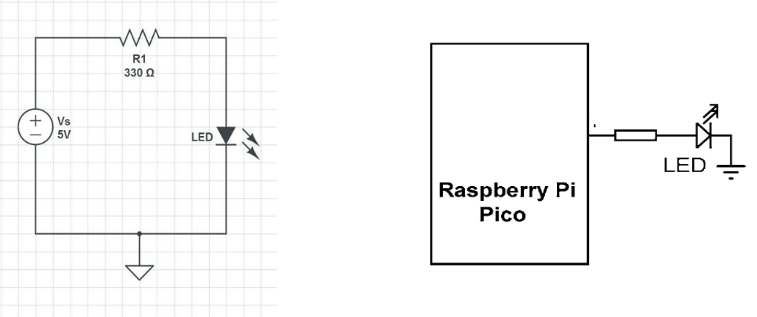

330


GP28

(Figure 1 : Simple LED Circuit for blinking an LED) (Figure 2: Hardware Implementation to blink an LED)

Objective 6
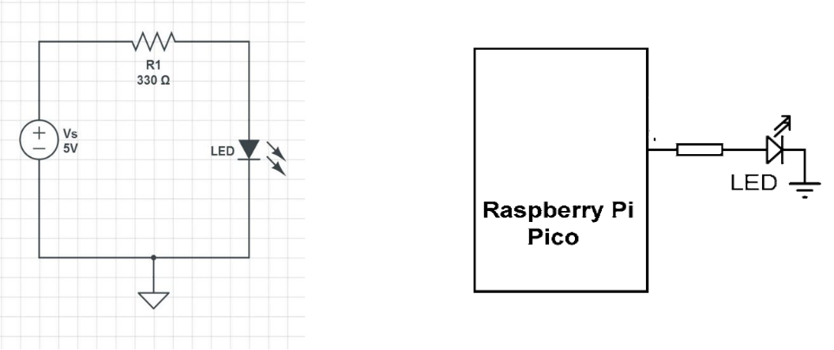

330


GP28

(Figure 3: Hardware Implementation to blink both on-board & external LED using Raspberry Pi Pico.)

Observation:

Objective 4

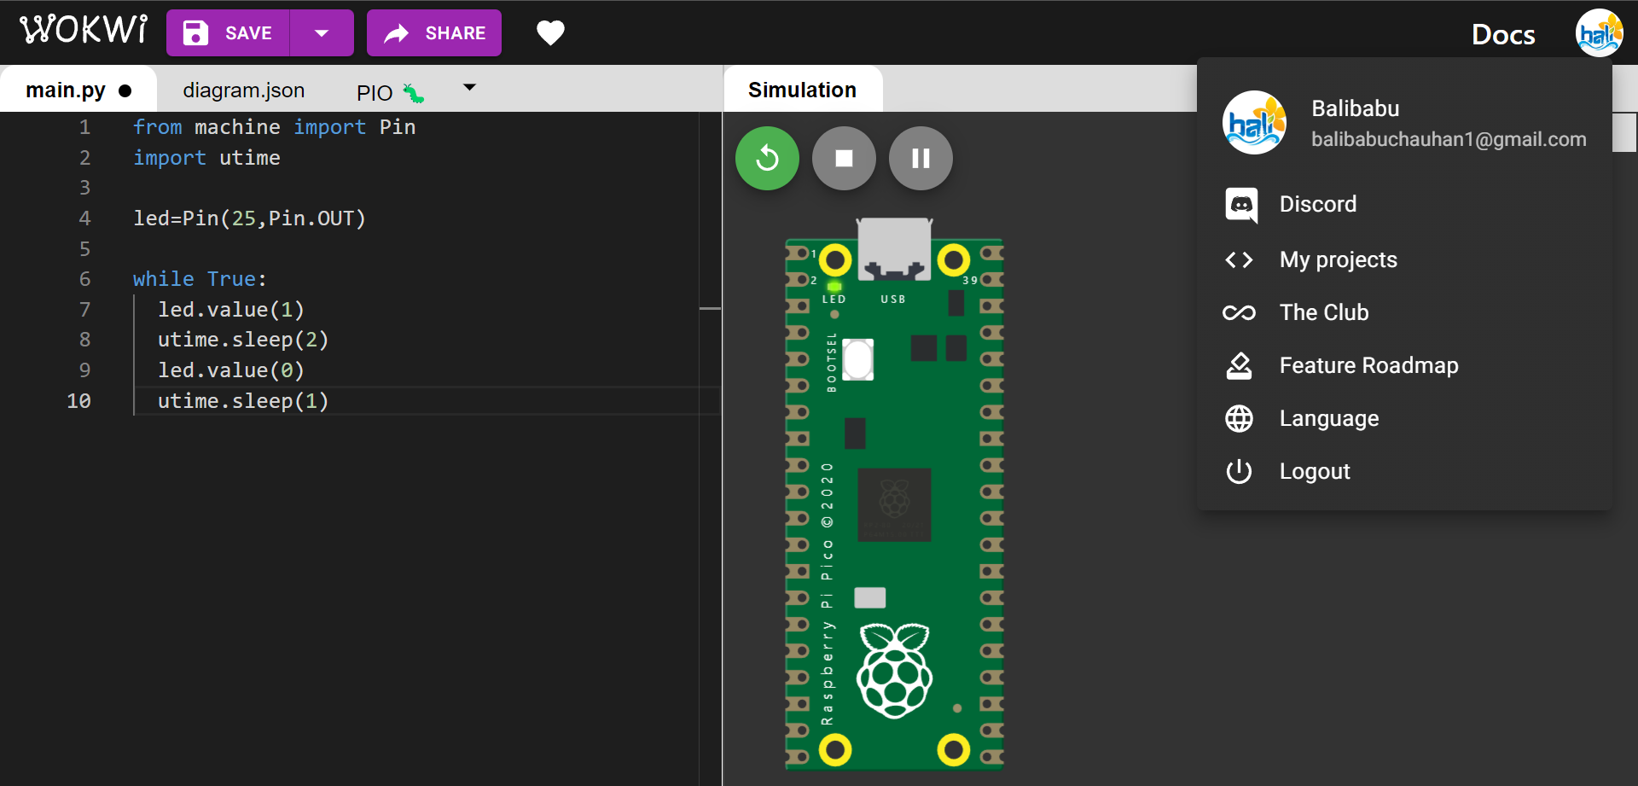

Figure 4: (Simulation based onboard LED blinking of Raspberry Pi Pico.)

INTERNET OF THINGS (IOT) PROJECT USING PYTHON (CSE 4110)
Familiarization with Internet of Things (IoT) concepts and getting started with Raspberry Pi.

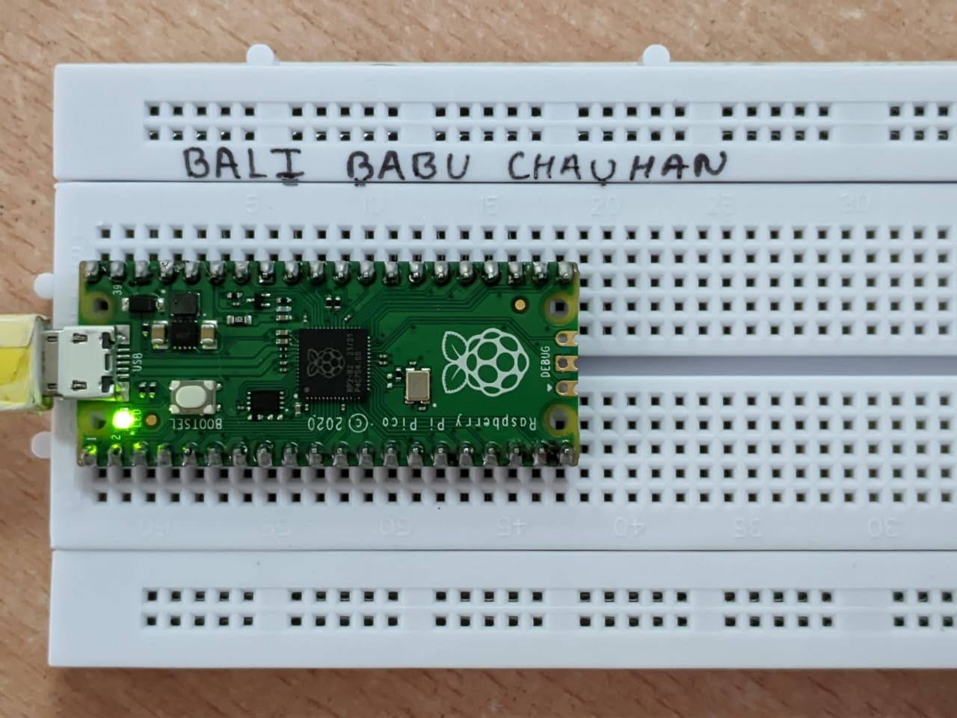
Figure 5: (Hardware Implementation based onboard LED blinking of Raspberry Pi Pico.)

Objective 5

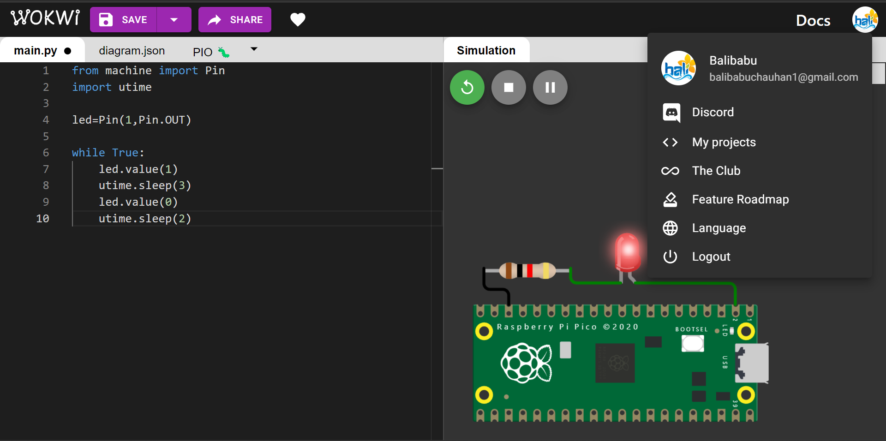

Figure 6: (Simulation based Simple External LED Circuit for blinking an LED using Raspberry Pi Pico)

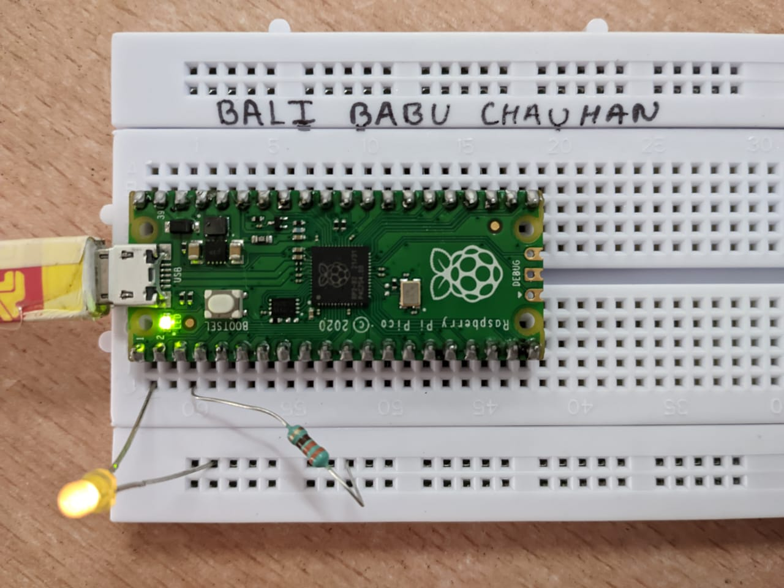

Figure 7: (Hardware Implementation based Simple External LED Circuit for blinking an LED using Raspberry Pi Pico)

INTERNET OF THINGS (IOT) PROJECT USING PYTHON (CSE 4110)
Familiarization with Internet of Things (IoT) concepts and getting started with Raspberry Pi.

Objective 6

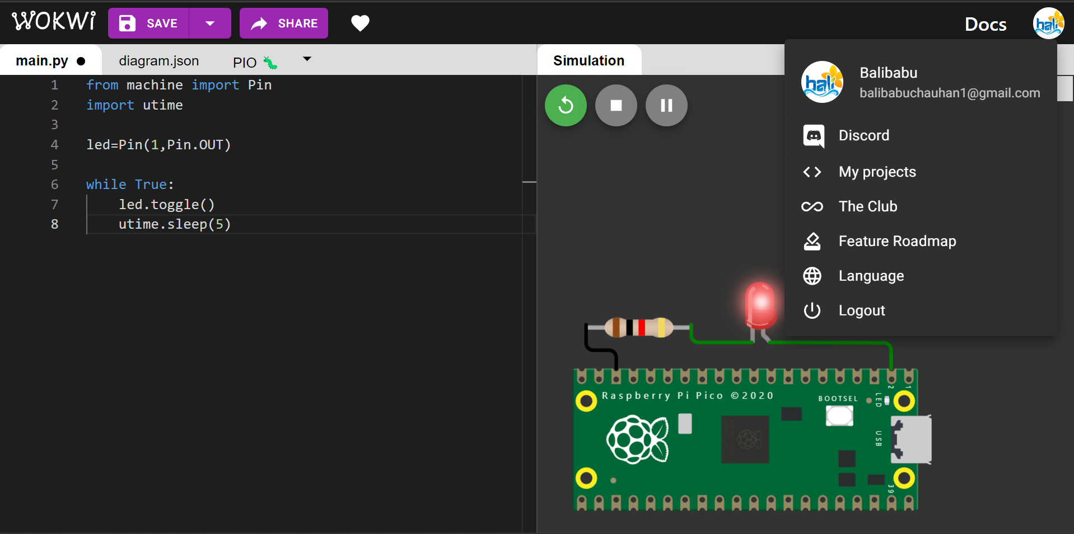

Figure 8: (Simulation based setup to blink both on-board & external LED using Raspberry Pi Pico.)

Figure 9: (Hardware Implementation based setup to blink both on-board & external LED using Raspberry Pi Pico.)

Codes:
Objective 4

print("Hello, Pi Pico!")

print("This is Experiment - 1 and Objective - 4")

print("Objective : 4 Familiarization with Online Simulator “WOKWI” and getting started with onboard LED blinking of Raspberry Pi Pico. ")
from machine import Pin

from utime import sleep
ledPin = Pin(25, Pin.OUT)

while True:

ledPin.value(1)

sleep(2)

ledPin.value(0)

sleep(1)

Objective 5

print("Hello, Pi Pico!")

print("This is Experiment - 1 and Objective - 5")

print("Objective : 5 To build our first external circuit and control it from the Raspberry Pi Pico i.e. ON for 3 seconds and OFF for 2 seconds. ")

from machine import Pin

from utime import sleep

ledPin = Pin(28, Pin.OUT)

while True:

ledPin.value(1)

sleep(3)

ledPin.value(0)

sleep(2)

Objective 6

print("Hello, Pi Pico!")

print("This is Experiment - 1 and Objective - 6")

print("Objective : 6 To implement a hardware setup to blink both on-board & external LED using Raspberry Pi Pico ON for 5 seconds and OFF for 5 seconds.")

from machine import Pin

from utime import sleep

ledPin1 = Pin(25, Pin.OUT)

ledPin2 = Pin(28, Pin.OUT)

while True:

ledPin1.toggle()

ledPin2.toggle()

sleep(5)

